Hands-on 6 - Find a Country Based on Country Code

Name: Shubham Sangram Bej

Aim
To retrieve a country from the database using its country code through Spring Data JPA and implement exception handling using a custom exception class.

Theory
- Spring Data JPA provides the findById() method to retrieve an entity using its primary key.
- Since the requested entity may or may not exist, findById() returns an Optional<T> object.
- The Optional class helps avoid NullPointerException by explicitly representing the presence or absence of a value.
- The @Transactional annotation ensures that Spring manages the Hibernate session and database transaction automatically during execution of the service method.
- A custom exception (CountryNotFoundException) is created to handle cases where the specified country code does not exist in the database.

Procedure
- Create the package service.exception.
- Create the CountryNotFoundException class.
- Add the findCountryByCode() method to CountryService.
- Use countryRepository.findById() to retrieve the country.
- Throw CountryNotFoundException if the country is not found.
- Create a test method in OrmLearnApplication.
- Execute the application and verify the retrieved country details in the console.

Screenshots
Project Structure showing CountryNotFoundException
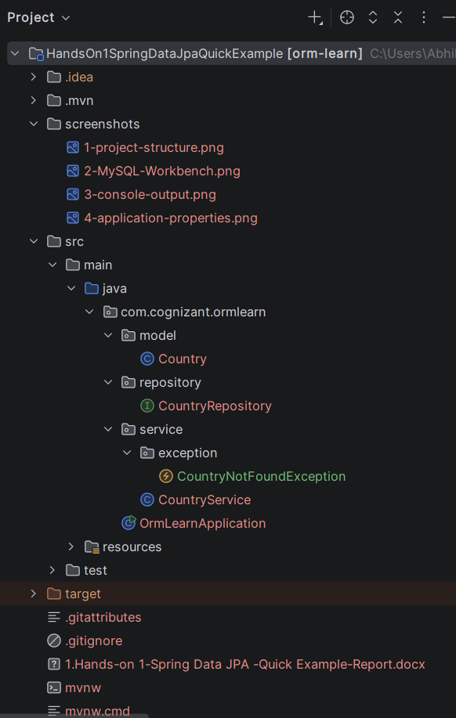

CountryService.java
package com.cognizant.ormlearn.service;
import com.cognizant.ormlearn.model.Country;
import com.cognizant.ormlearn.repository.CountryRepository;
import org.springframework.beans.factory.annotation.Autowired;
import org.springframework.stereotype.Service;
import org.springframework.transaction.annotation.Transactional;
import java.util.Optional;
import com.cognizant.ormlearn.service.exception.CountryNotFoundException;
import java.util.List;
@Service
public class CountryService {
@Autowired
private CountryRepository countryRepository;
@Transactional
public List<Country> getAllCountries() {
return countryRepository.findAll();
}
@Transactional
public Country findCountryByCode(String countryCode) throws CountryNotFoundException {
Optional<Country> result = countryRepository.findById(countryCode);
if (!result.isPresent()) {
throw new CountryNotFoundException("Country not found with code: " + countryCode);
}
Country country = result.get();
return country;
}
}

CountryNotFoundException.java

package com.cognizant.ormlearn.service.exception;
public class CountryNotFoundException extends Exception {
public CountryNotFoundException(String message) {
super(message);
}
}

Country.java
package com.cognizant.ormlearn.model;
import jakarta.persistence.Column;
import jakarta.persistence.Entity;
import jakarta.persistence.Id;
import jakarta.persistence.Table;
@Entity
@Table(name = "country")
public class Country {
@Id
@Column(name = "co_code")
private String code;
@Column(name = "co_name")
private String name;
public Country() {
}
public Country(String code, String name) {
this.code = code;
this.name = name;
}
public String getCode() {
return code;
}
public void setCode(String code) {
this.code = code;
}
public String getName() {
return name;
}
public void setName(String name) {
this.name = name;
}
@Override
public String toString() {
return "Country{" +
"code='" + code + '\'' +
", name='" + name + '\'' +
'}';
}
}

OrmLearnApplication.java
package com.cognizant.ormlearn;
import com.cognizant.ormlearn.model.Country;
import com.cognizant.ormlearn.service.CountryService;
import org.slf4j.Logger;
import org.slf4j.LoggerFactory;
import org.springframework.boot.SpringApplication;
import org.springframework.boot.autoconfigure.SpringBootApplication;
import org.springframework.context.ApplicationContext;
import java.util.List;
@SpringBootApplication
public class OrmLearnApplication {
private static final Logger LOGGER =
LoggerFactory.getLogger(OrmLearnApplication.class);
private static CountryService countryService;
public static void main(String[] args) {
ApplicationContext context =
SpringApplication.run(OrmLearnApplication.class, args);
LOGGER.info("Inside main");
countryService = context.getBean(CountryService.class);
testGetAllCountries();
testFindCountryByCode();
}
private static void testGetAllCountries() {
LOGGER.info("Start");
List<Country> countries = countryService.getAllCountries();
LOGGER.debug("countries={}", countries);
LOGGER.info("End");
}
private static void testFindCountryByCode() {
LOGGER.info("Start");
try {
Country country = countryService.findCountryByCode("PT");
LOGGER.debug("Country={}", country);
} catch (Exception e) {
LOGGER.error(e.getMessage());
}
LOGGER.info("End");
}
}

Console Output showing retrieved country details
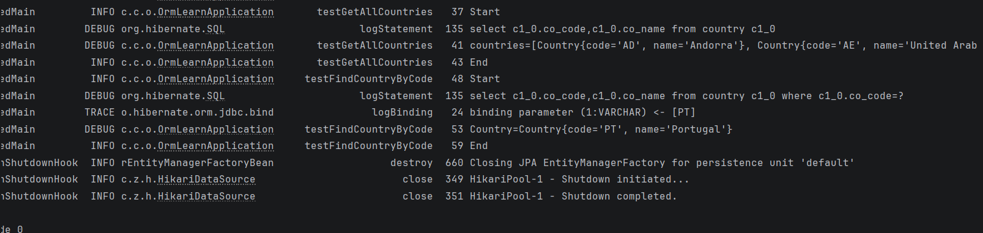

Result
The application successfully retrieved the country details based on the specified country code using Spring Data JPA.

Conclusion
The findById() method of Spring Data JPA was successfully used to retrieve a country from the database. The implementation also demonstrated the use of Optional, @Transactional, and custom exception handling to ensure reliable database operations.

